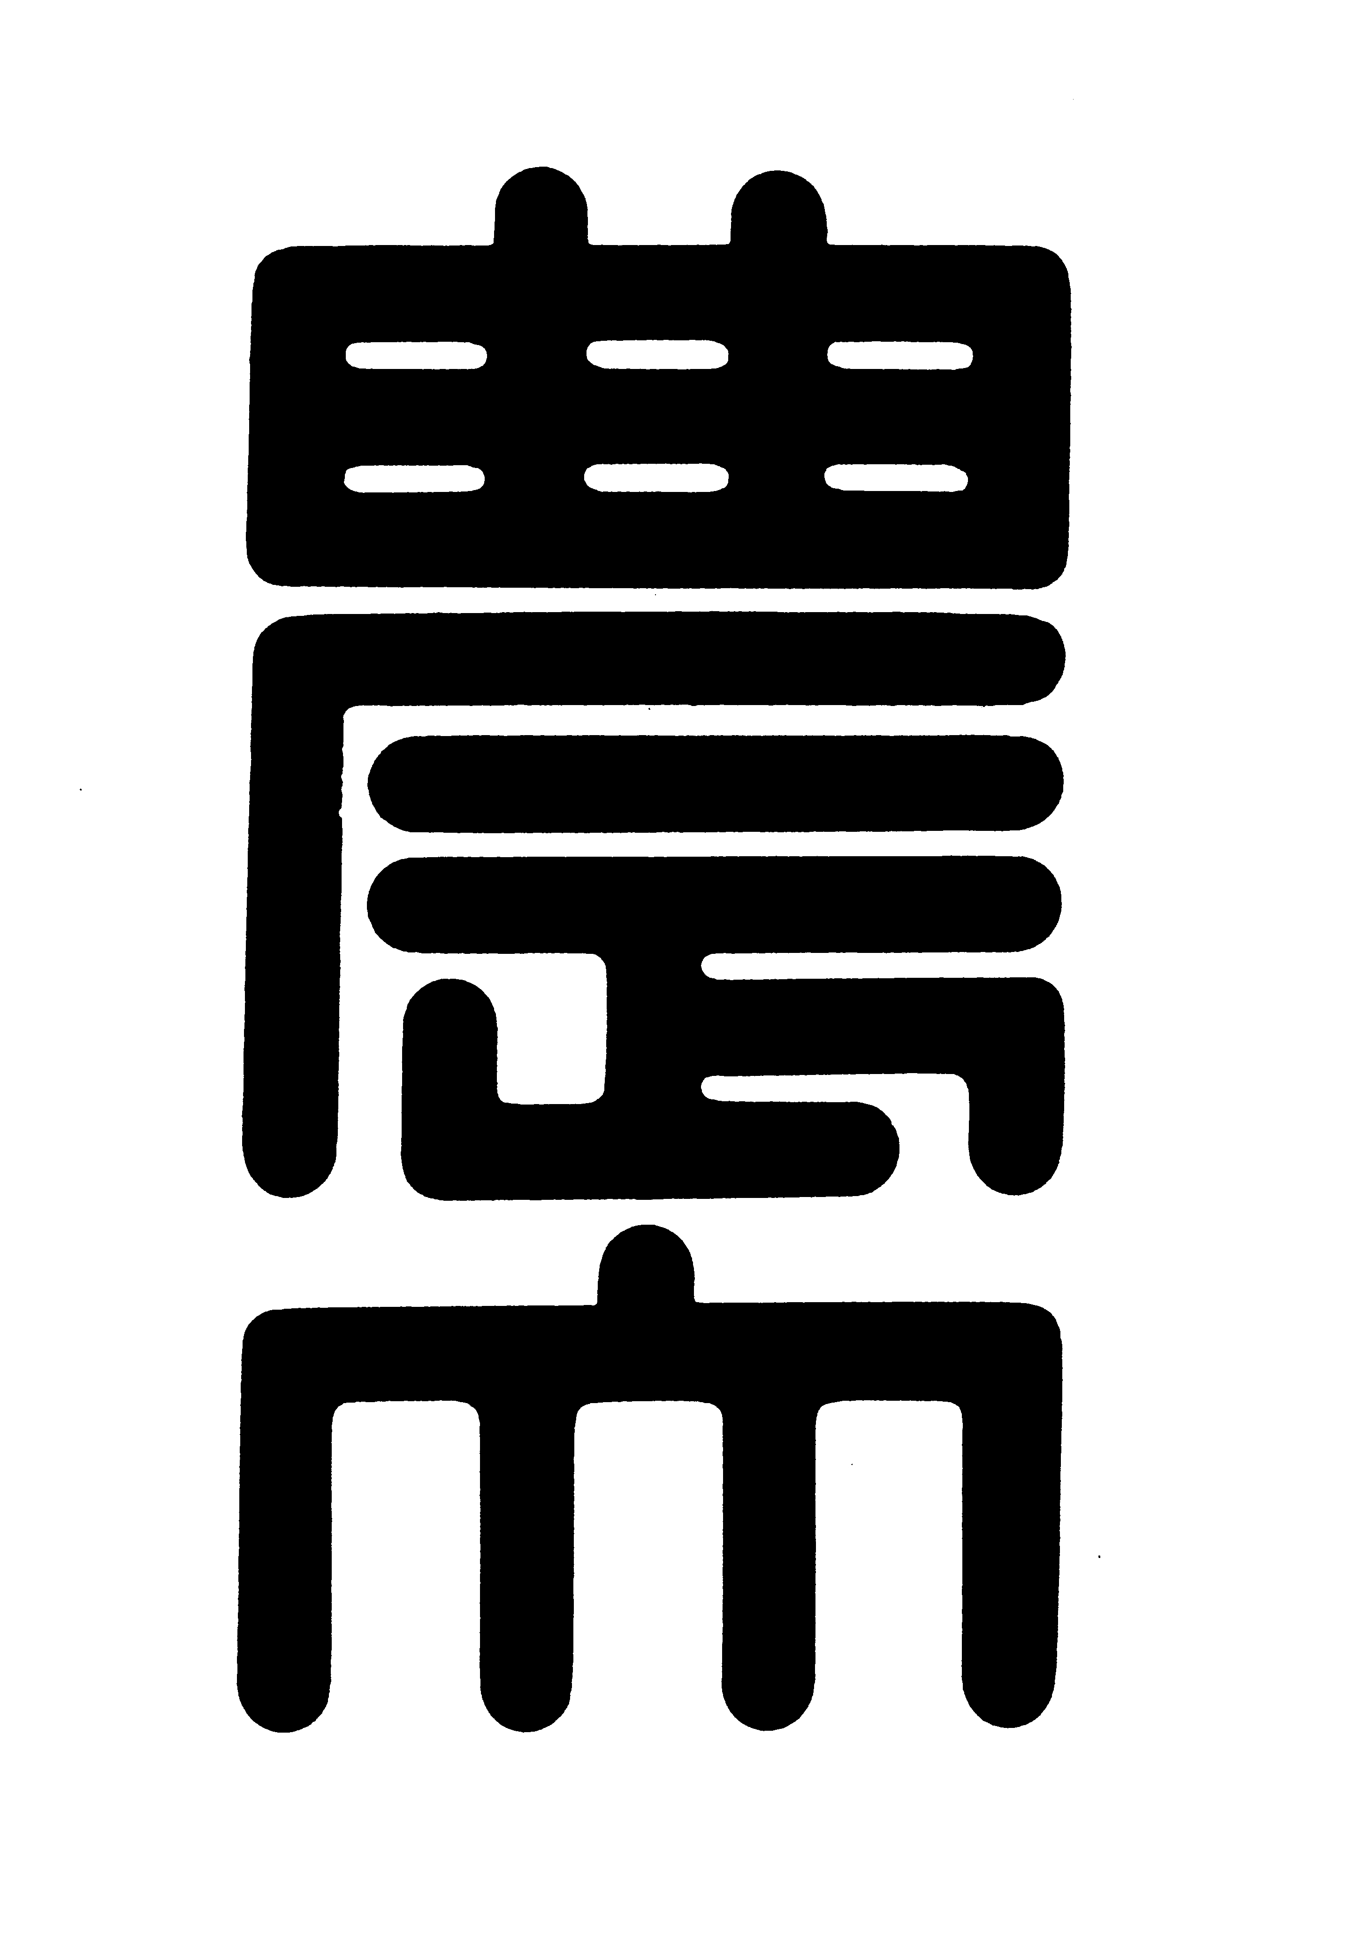
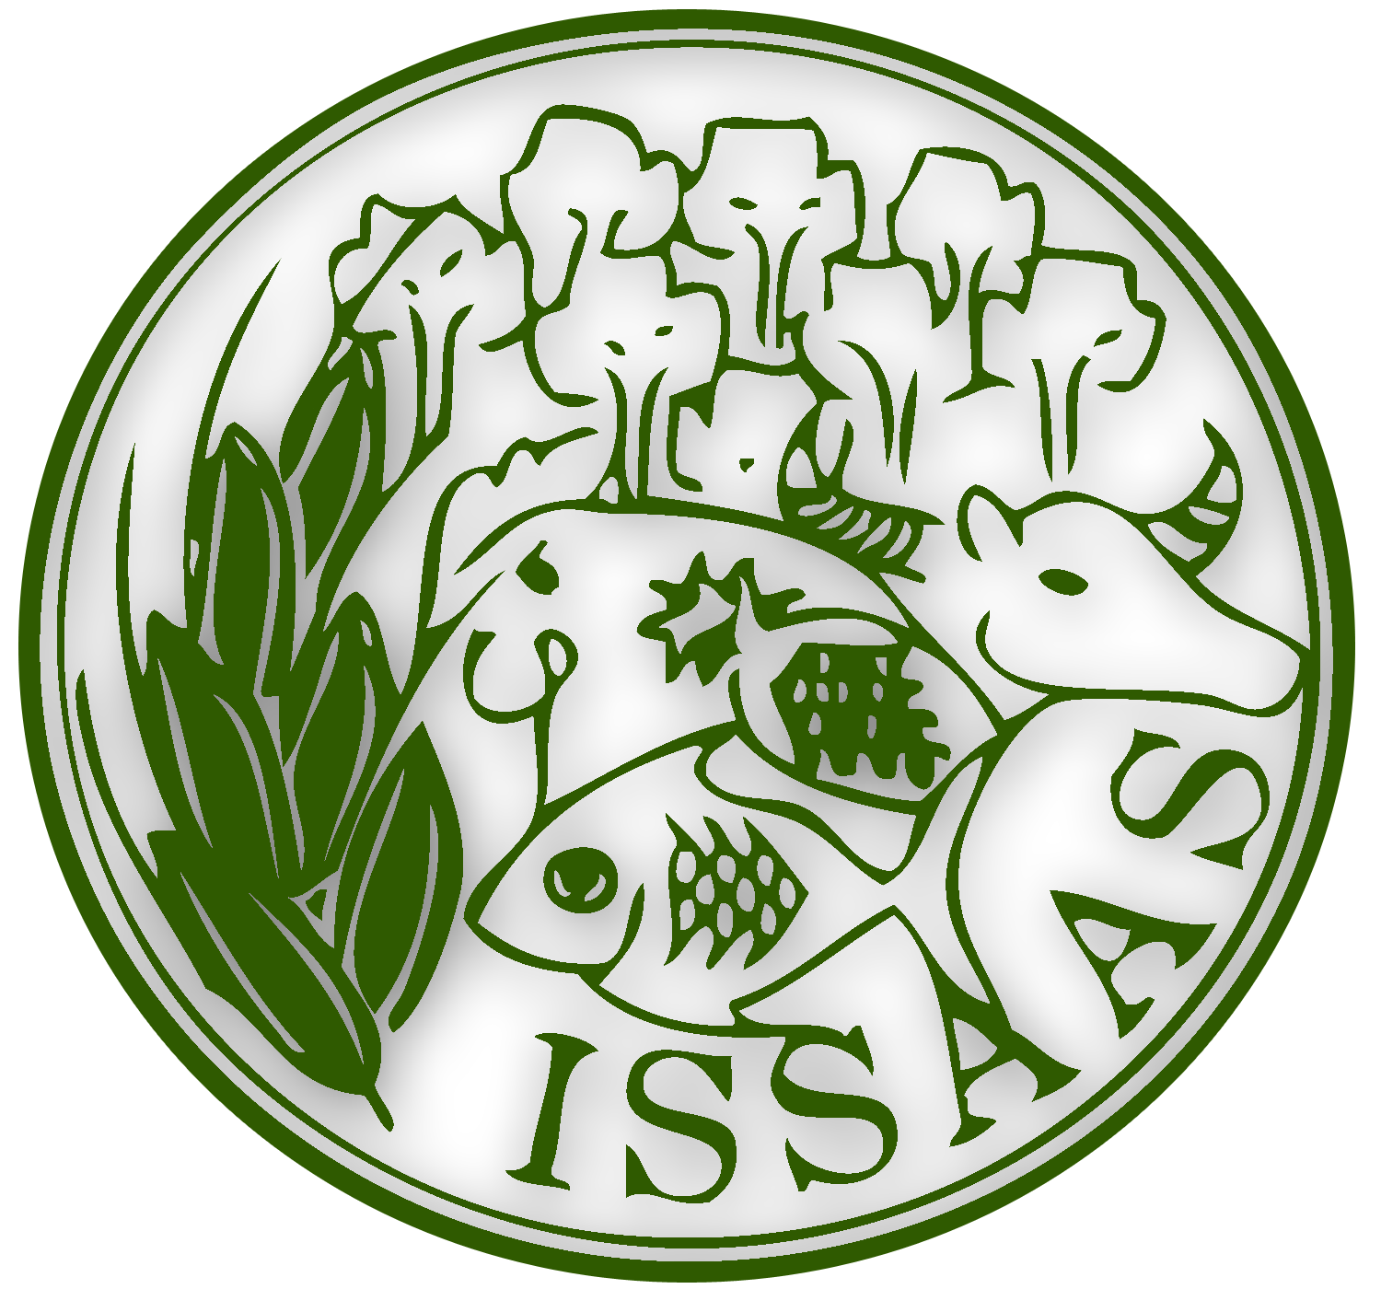
2014 ISSAAS International Congress and General Meeting
November 8-10, 2014
NODAI Academia Center, Tokyo University of Agriculture
Tokyo, Japan

CONGRESS TOUR FORM

- HEAD OF PARTY
Full name | : | Click here to enter text. | Click here to enter text. | Click here to enter text.
 |  | Surname | First Name | Middle Name
Title : ☐ Professor ☐ Dr. ☐ Mr. ☐ Mrs. ☐ Ms.
Country : Click here to enter text. Specify for others: Click here to enter text.
Institution | : | Click here to enter text.
E‐mail | : | Click here to enter text.

- Kindly list all the participants (including Head of Party):
Title  (Prof/Dr/Mrs/Ms/Mr) | Name | Sex  (M/F) | Birthday  (MM/DD/YYYY) | Name of Institution | Registration Paid  (Yes/No) | Name of Accommodation Facility/Hotel & Phone Number  (if any) | Avail option to enjoy Tokyo on their own after Asakusa?
 |  |  |  |  |  |  | Yes | No

- Total number: _____

NOTES:
- Although lunch will be provided, there are no special arrangements made for participants with dietary restrictions, related to religious or medical reasons, and such participants are requested to bring their own food.
- For those who wish to enjoy Tokyo more then go back to the hotel on their own, there is an option to leave the tour group at Asakusa from 16:00pm before the tour group leaves for Tokyo NODAI.
- Kindly submit this form and send to issaas14@nodai.ac.jp on or before 8 October 2014, with subject heading Congress Tour.

