
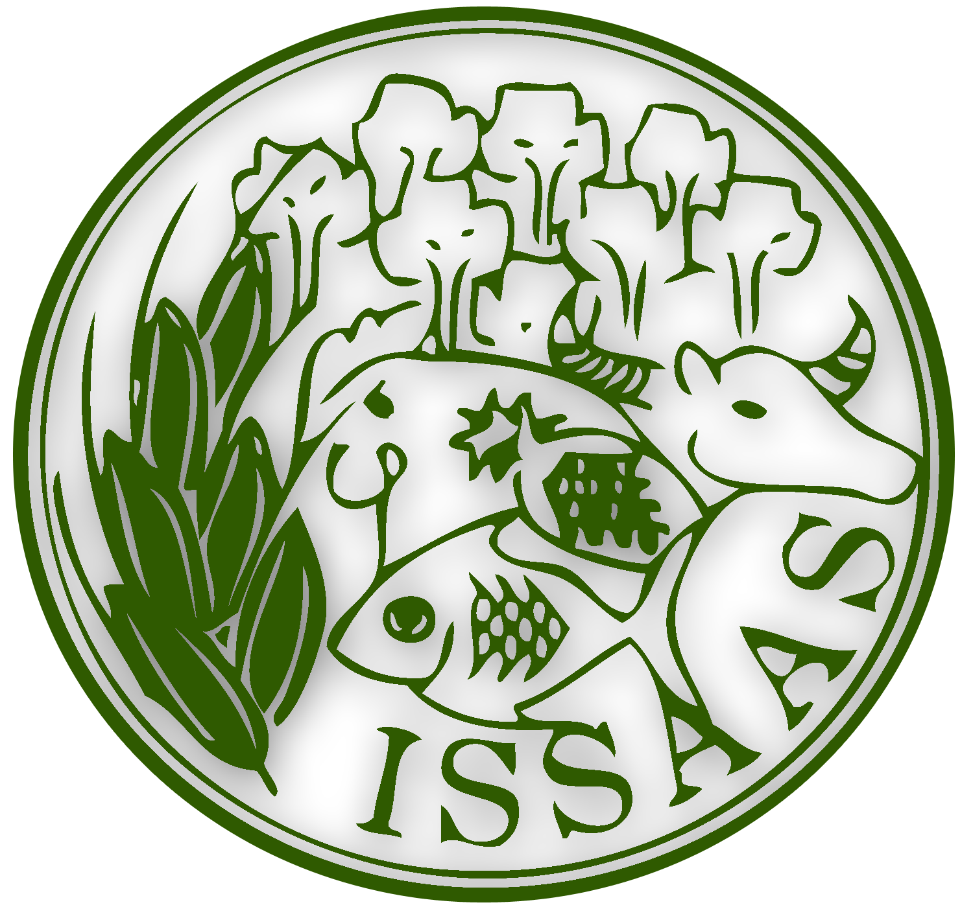
2014 ISSAAS International Congress
And General Meeting
November 8-10, 2014
NODAI Academia Center, Tokyo University of Agriculture
Tokyo, Japan

REGISTRATION FORM

Full name | : | Click here to enter text. | Click here to enter text. | Click here to enter text.
 |  | Surname | First Name | Middle Name
Title : ☐ Professor ☐ Dr. ☐ Mr. ☐ Mrs. ☐ Ms.
Country : Click here to enter text. Specify for others: Click here to enter text.

Institution | : | Click here to enter text.
Address | : | Click here to enter text.
E‐mail | : | Click here to enter text.
Tel. No. | : | Click here to enter text.
Fax No. | : | Click here to enter text.

1. I wish to (please tick “x” where applicable):

☐ | Make an oral presentation | ☐ | Present a poster | ☐ | Be a member participant only

Title of Paper/Poster: (Please attach abstract)
Click here to enter text.

2. Please tick (“x”) the discipline of your paper:

☐ | Plant Production and Environmental Agriculture | ☐ | Agro-Engineering
☐ | Agricultural Chemistry | ☐ | Animal Life Science
☐ | Aquatic Science | ☐ | Agricultural Science in Society and Economy
☐ | Forest and Forest Products Science | ☐ | Boundary Agriculture

3. Registration Fees

Category of Participant | Registration
Local and International Members | 15,000 yen
Student Members | 10,000 yen
Non-Members | 20,000 yen
* This includes lunch, dinner and coffee breaks for November 8 and 9, congress tour on November 10 and conference kit. Although meals will be provided, there are no special arrangements made for participants with dietary restrictions related to religious or medical reasons, and such participants are requested to bring their own food.
* Student members are requested to submit a copy of their student ID or similar document upon submission of the registration form.

4. Paypal Receipt No./Transaction ID: ___________ Date Paid _______________

Deadline for Submission of abstracts is September 15, 2014. Abstracts can be sent by email to issaas14@nodai.ac.jp with the subject heading Abstract for 2014 ISSAAS, attached with the filled-up registration form and receipt of registration payment. Since only active ISSAAS members (paid annual dues) may present a scientific paper or poster, kindly confirm your membership at your respective chapters in advance. For those who will be member participant only, kindly send the registration form with the subject heading Registration for 2014 ISSAAS.

Kindly visit the ISSAAS Congress 2014 Webpage (http://www.nodai.ac.jp/issaas/issaas2014) for the registration fee payment via Paypal.

For more information, please contact:
The ISSAAS Congress Secretariat
E-mail: issaas14@nodai.ac.jp

